KARAATLI FATMA CUMA ALİ YILMAZ
İMAM HATİP ORTAOKULU
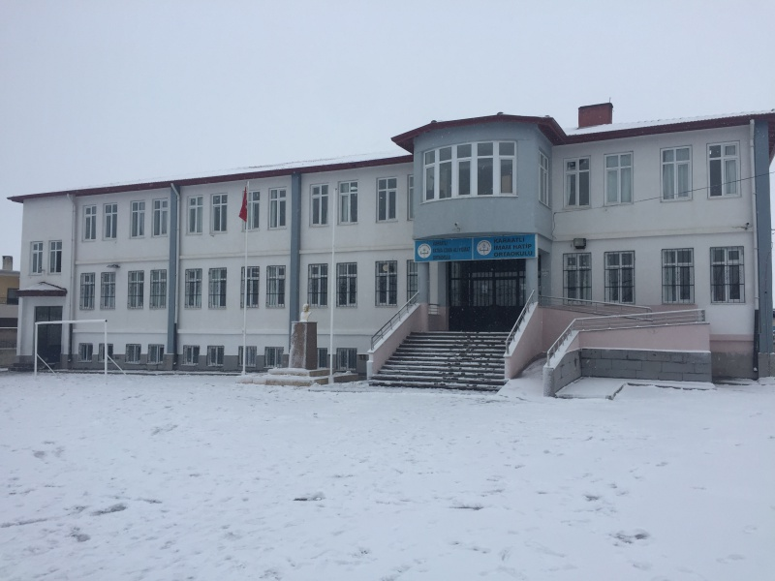

http://fatmacumaaliyilmaziho.meb.k12.tr/
https://www.youtube.com/channel/UCfbZ16nmhMLjWVVG3WujgcA/featured
https://www.facebook.com/Karaatli-Fatma-Cuma-Ali-Y%C4%B1lmaz-%C4%B0mam-Hatip-Ortaokulu-106721374436084/
https://www.instagram.com/fcayiho/?hl=tr
https://twitter.com/fcayiho

